EXPECTED OUTPUT
Emergency Shelter Allocation Platform
A Nationally-Scalable, Multi-Hazard Disaster Shelter Allocation System — Pilot: Assam (Flood Response)
Review 1 | Course: CSS7102 | Presidency University
Team: Sharan (Team Lead), Harshil Gurjar, Suhas | Guide: Mr. Irfan Rajab Bhat
29 August 2026

1. Why the Output Matters
The purpose of the Emergency Shelter Allocation Platform is not to produce a single number or report, but to produce a decision a relief coordinator can act on within minutes of opening the dashboard, instead of hours of manual map-reading and phone calls. Every output described in this document is therefore judged against one standard: does it tell a coordinator, in an active disaster, exactly which population group should go to which shelter, how many people that shelter can safely hold, and where the system is uncertain or unable to fully meet demand. This document sets out, stage by stage, what the working prototype is expected to produce, using realistic sample data for the Assam flood pilot, and closes with the criteria against which Review 2 and the Final Review will judge whether the system actually works.

2. Output at Each Pipeline Stage
Stage | Output Produced | Where It Is Seen
1 | Filtered, scored, capacity-estimated shelter list | Map of candidate vs. suitable buildings (Dashboard Section 2)
2 | Pending population-group records | Table of groups awaiting allocation (Dashboard Section 1)
3 | Distance/time matrix, top-N shelters per group | Internal to Stage 4; not shown directly to the coordinator
4 | Feasible allocation, or allocation plus waitlist | Allocation results table (Dashboard Section 3)
5 | Committed rows in allocations, shelters, population_groups | Auditable database state; not shown directly, but drives Stage 6/7
6 | Live map with occupancy shading and allocation lines | Dashboard Section 3 map
7 | One coordinator-facing screen tying all of the above together | The Streamlit application itself

3. Expected Dashboard Layout
The wireframe below shows the expected layout of the Streamlit dashboard once Stages 0–7 are wired together. It is a layout sketch, not a screenshot — exact styling will follow whatever Streamlit's default theme produces — but the section structure, the single allocation trigger, and the four result panels are fixed design decisions carried over directly from the Architecture Design document.
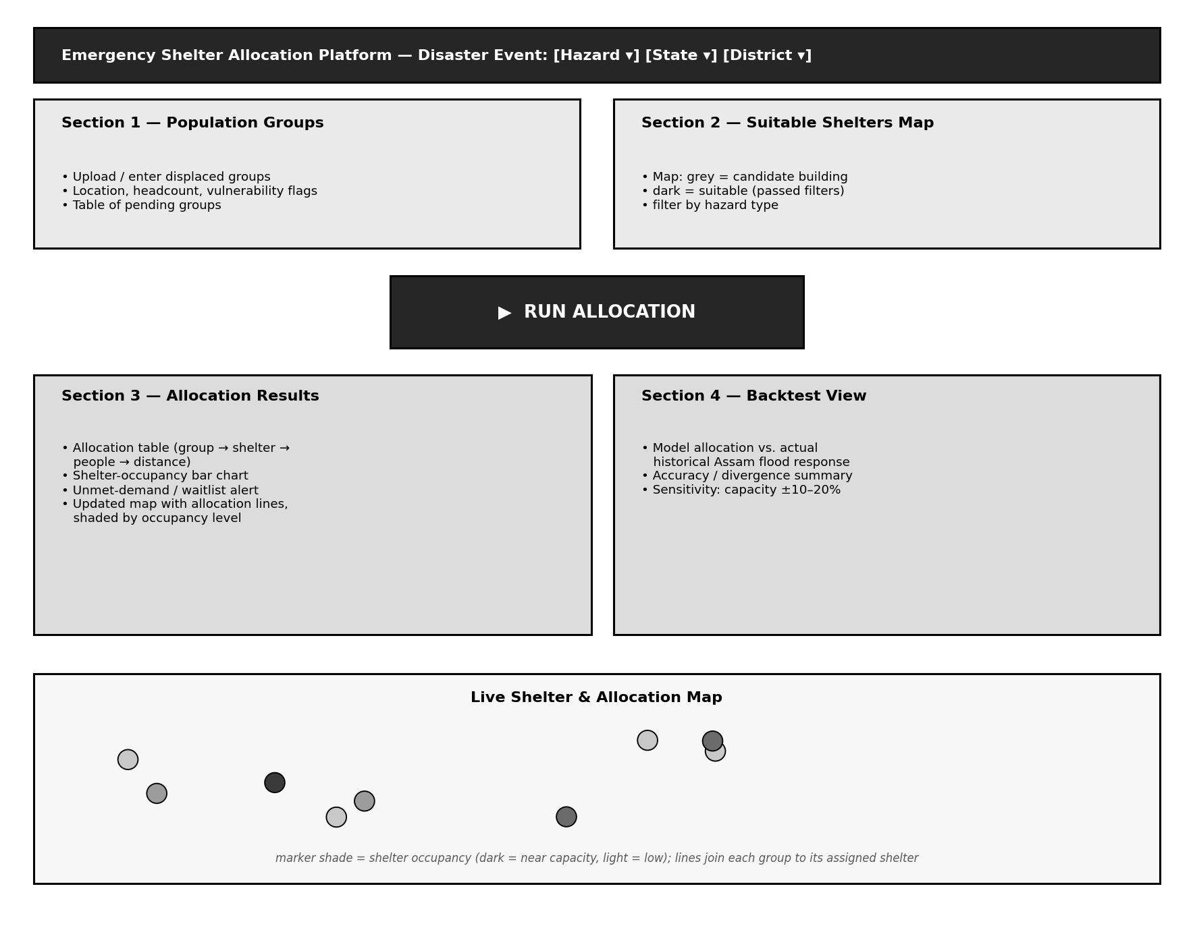
Figure 1. Expected dashboard layout — population input and shelter map on top, a single allocation trigger, then results and backtest panels, with a live map at the bottom.

4. Sample Expected Data Output
The tables below are illustrative samples — built with realistic Assam-district-style values — to show the exact shape of data the system is expected to produce, not real field data. They exist so the review panel can see precisely what a 'suitable shelter' record and an 'allocation result' record will actually contain.

4.1 Sample Output — Suitable Shelters Table (Stage 1)
Shelter Name | Building Type | Est. Capacity | Flood Flag | Road Access
Govt. Higher Sec. School, Panbari | School (2 floors) | 410 | Suitable | Yes
Community Hall, Dighalia | Community hall (1 floor) | 185 | Suitable | Yes
Block Development Office, Rangia | Government building | 260 | Suitable | Yes
Riverside Primary School, Char area | School (1 floor) | 95 | Excluded — in flood polygon | No
Note the fourth row: this is a deliberate sample of a building the system is expected to correctly discard — close to the affected population but sitting inside the mapped flood-inundation polygon, and also lacking mapped road access. Producing this kind of visible exclusion, not just a list of accepted shelters, is itself part of the expected output, since it is what makes Stage 1's reasoning auditable.

4.2 Sample Output — Allocation Results Table (Stage 4–5)
Group ID | Assigned Shelter | People Assigned | Distance (km) | Mode
PG-014 | Govt. Higher Sec. School, Panbari | 62 | 3.1 | Routed
PG-015 | Community Hall, Dighalia | 140 | 2.4 | Routed
PG-016 | Block Development Office, Rangia | 205 | 5.8 | Estimated
PG-017 | Waitlisted — no remaining capacity within range | 38 | — | —
The 'Mode' column expected here — Routed vs. Estimated — is a direct, visible expression of the Stage 3 fallback design: whenever OpenRouteService could not be reached, the system is expected to still produce an allocation, but to say honestly that the distance shown is a straight-line estimate rather than a road-network measurement. The fourth row is an expected waitlist case, produced deliberately by testing the pipeline with more displaced people than nearby capacity can absorb.

5. Expected Backtesting Output
Because Section 4 of the Architecture Design document commits this project to validating itself against a real Assam flood event rather than synthetic data alone, the backtest view is expected to produce three specific outputs, not just a single accuracy number:
- Coverage check — what percentage of the shelters actually used during the real historical event were also independently flagged 'suitable' by Stage 1. A high overlap is expected, since the real coordinators presumably also avoided obviously unsafe buildings; any real shelter that Stage 1 would have rejected is expected to be reported explicitly, with the specific rule that rejected it, rather than silently ignored.
- Distance comparison — the average distance produced by the model's allocation compared against the average distance implied by the actual historical allocation, for the same population figures. The model is expected to perform at least as well as the historical response on this measure, since it is solving an explicit minimisation problem the manual response was not.
- Sensitivity output — the allocation is expected to be re-run with every shelter's estimated capacity deliberately perturbed by ±10% and ±20%, and the resulting change in how many groups switch shelters or become waitlisted is expected to be reported as a simple before/after count — giving the panel a concrete, numeric answer to 'how sensitive is this to your capacity assumption being wrong'.

6. Success Criteria for This Prototype
For Review 2 and the Final Review, the following outcomes define whether the expected output has actually been achieved, not just attempted:
- Feasibility. For a given sample event, the solver returns an allocation in which no shelter's assigned people exceed its estimated capacity.
- Honesty under shortage. When total demand exceeds total nearby capacity, the system reports an explicit waitlist rather than overcrowding a shelter or failing silently.
- Graceful degradation demonstrated live. The panel can be shown a run with OpenRouteService deliberately disabled, and the system still produces a complete allocation using haversine-estimated distances, correctly labelled.
- Multi-hazard pluggability demonstrated live. Switching the active event's hazard type from flood to a second hazard changes which suitability rules run, without any code change.
- Backtest plausibility. The Section 5 comparison against the real Assam flood event shows a reasoned, documented level of agreement — not necessarily a perfect match, but an explainable one.
- Auditability. Every allocation shown on the dashboard can be traced back to a specific row in the allocations table with a timestamp, satisfying the transactional persistence design from Stage 5.

7. Anticipated Review Questions on Expected Output
The following questions are anticipated from the panel specifically about output and usefulness, with the short answer this project gives to each.
Likely Question | Short Answer
Will the coordinator actually see where each shelter is located? | Yes — every shelter is plotted on an interactive map with its name, coordinates, capacity and live occupancy; allocation lines connect each population group to its assigned shelter.
How is this different from a coordinator just looking at Google Maps manually? | Manual review cannot check hundreds of buildings against flood polygons and solve a capacity-constrained assignment across many groups in minutes; the system automates exactly that, and records why each decision was made.
What happens if the internet or an API goes down mid-disaster? | Every external dependency has a documented, demonstrated fallback (Section 8 of the Architecture Design document); the system keeps producing an allocation, with lower-confidence data flagged rather than hidden.
Is the output specific to Assam, or does it generalise? | The pipeline code is state- and hazard-agnostic by construction; Assam flood response is the validated pilot, not a hardcoded case — changing the Stage 0 event parameters is expected to be sufficient to run the same pipeline elsewhere.

